**Leader Overview**



**Volume Overview**

**How do I fulfill God’s mission?**

*Christianity is so much more than only another religion. It’s not just another collection of rules and regulations. It’s a real relationship with Jesus Christ. When we give our heart to Jesus, He becomes our Savior and our Lord. Life is not only full of responsibilities, bills, and work, but it can also be full of eternal purpose.*

*As we grow closer to God, He begins to reveal His true purpose and plans for our life. We begin to discover the personal mission and assignment He has designed for each of us. While we may have different gifts, talents, and abilities, each of us is called to the same mission of helping to transform the world with God’s love and power. God calls us to personally share our faith, to help lead others toward a deeper walk with Christ, and to help others fulfill their individual mission. As we lean into God and allow Him to make a difference in our life, He will in turn use us to make a difference in the life of others.*

**Session Overview**

**I Share My Faith**

*In our Bible story, Paul shared his faith with people in the city of Athens who worshipped false gods. Paul knew that everyone needs to hear about Jesus. So even when it was difficult, Paul was ready to tell people about God. We must also be ready to tell others about how God has changed our life. Our story can help point them to Jesus and salvation through Him.*

**Bible Lesson**

Paul Shares the Good News

[Acts 17:16–34](https://ref.ly/logosref/Bible.Ac17.16-34)

**Faith Fact**

I will tell others about Jesus.

**Faith Verse**

[Matthew 28:19](https://ref.ly/logosref/Bible.Mt28.19) (NLT)

“Therefore, go and make disciples of all the nations, baptizing them in the name of the Father and the Son and the Holy Spirit.”

**Preparing for the Session**

**Leader Preparation Time: 20–25 Minutes**

|  |
| --- |
| ***You Will Need***  ***Large Group***   * *Bible* * *Worship songs (Song suggestions: “Tell His Story” lyric video by Yancy; “Real Love” lyric video by Hillsong Young & Free; “For the One” by Brian and Jenn Johnson; “Build My Life” by Passion)* * *For groups not using a phone or tablet only, add:*   *• Projector or TV*  *• Laptop*  *•* ***Countdown60 Video****–60 seconds*  *•* ***Faith Fact Slide***  *•* ***Faith Verse Video*** *or* ***Slide***  *•* ***Bible Lesson Video***  *•* ***Teaching Point Slides 1–3***  *• Balloons, ten or more depending on the size of your group*  *• Dominoes*  *• Table*  *• Optional: Masking tape*  *• Optional: Marker*  ***Small Group***   * ***Small Group Faith Verse Review Page****, one or more per group* * *Card stock* * *Paper cutter or scissors* * *Envelopes, one per group* * ***Small Group Activity Page****, one per kid* * *Crayons or markers*   *To access session content and videos from a computer, visit:* [*BibleEngagementProject.com/downloads*](https://bibleengagementproject.com/downloads) |
| ***Getting Ready***  ***Large Group***   * *Download videos and slides if needed.* * *Select worship song(s) and have them ready to play.* * *Read the Bible Lesson Scripture to prepare for Teaching Time.* * *Inflate the balloons with air (not helium).* * *Optional: Cover one domino with masking tape, draw a stick figure on it, and label it “Paul.”*   ***Small Group***   * *Print the* ***Small Group Faith Verse Review Page****, one or more per group.* * *Cut the Faith Verse puzzle into pieces. Place pieces for each puzzle in an envelope. Consider making more intricate cuts for older kids.* * *Print copies of the* ***Small Group Activity Page****, one per kid.*   *First time leading* Learn *for Kids? Check out the* [*Facilitator Guide*](https://0b769b0ed3569ef9d18b-f88d8272f61086866d50d048b43ef630.ssl.cf2.rackcdn.com/sites/biblengagementproject/Listen_Facilitator_Guide.pdf)*.* |

**Large Group**

**30 Minutes**

*See what’s needed at the beginning of the session.*

**Introduction**

Welcome, everyone! I’m so glad you’ve joined me today. We’re discovering the ways we can fulfill God’s mission to help people know Him better and get closer to Him. But before we get started, raise your hand if you have a crazy story to tell about something unique or special that happened to you. *(Group response)* Let’s see how many of you can share before this video ends. If I call on you, you’ll need to tell your story quickly.

• *Choose kids to share their stories as the video plays.*

• *Play the* ***Countdown60 Video****.*



What cool stories! I’m sure everyone here could share great stories if we had more time. It can be really fun to tell people about exciting experiences we’ve had. Did you know God wants us to share stories about our faith in Him too? *(Group response)* Today we’ll hear about someone in the Bible who told lots of people the best story ever—the story of what Jesus did for everyone. Let’s get started!

**Faith Fact**

There’s one special phrase I want you to remember today. Our Faith Fact is: **I will tell others about Jesus.**

• *Show the* ***Faith Fact Slide.***

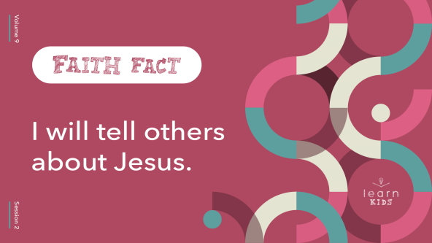

Let’s repeat it together to get it in our mind. Say it with me in a funny voice. **I will tell others about Jesus.** One more time! **I will tell others about Jesus.** Great job!

• *Optional: Call on kids to share the Faith Fact in the funny voice they chose.*

**Game**

**Share It All**

|  |
| --- |
| ***You Will Need***   * *Balloons, ten or more depending on the size of your group* * ***Countdown60 Video****–60 seconds*   ***Getting Ready***   * *Inflate the balloons with air (not helium).* |

Let’s play a game called Share It All. First, we’ll divide into two teams.

• *Divide the group in half. Show them where the middle boundary will be.*

I’ll give each team the same number of balloons to get started. Your goal is to “share” as many balloons as you can with the other team. When I say, “Go,” toss the balloons in the air and tap them to the other team’s side. You have one minute to hit as many balloons as possible to the other side. When balloons come to your side of the room, toss or hit them back. The team with the fewest balloons at the end of one minute wins. Let’s get started!

• *Play the* ***Countdown60 Video****.*



• *If you have time, play the game again. Try adding variations like using one hand, facing away from the middle of the room so kids can’t see where they’re aiming, using their heads to push the balloons, etc.*

Wow, you did a great job! You really gave it everything you had so the balloons could travel as far as possible. You know, that kind of reminds me of our Faith Fact today. Let’s say it. **I will tell others about Jesus.** When we tell people about Jesus, we should give it everything we have! In a few minutes, we’re going to talk more about someone who had lots of energy and passion for sharing Jesus with others.

**Worship**

I’m so thankful for Jesus. And we get to tell other people about Jesus too! Who’s ready to worship Him? *(Group response)* Let’s sing and worship now.

• *Lead the kids in singing one or two praise songs. See suggestions at the beginning of the session.*

**Bible Lesson**

Thanks for worshipping Jesus with me today! Now it’s time for us to dive into God’s Word. Have you ever wondered if you have a part in God’s mission to help people know Him better and get closer to Him? God’s plan is big, and sometimes we might feel too small to do much. But today we’ll find out about someone in the Bible who fulfilled God’s mission by telling people what Jesus had done for him. That sounds like something we can all do! Before we check out the Bible story, let’s pray.

**Prayer**

|  |
| --- |
| *Dear God, thank You for Your Word. Please help us learn how we can fulfill Your mission by sharing Your story with others. Amen.* |

**Video Intro**

Just before we talk more about the Bible story, let’s take a look at this video.

• *Play* ***Bible Lesson Video****.*

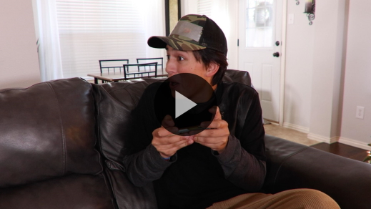

**Bible Story**

**Paul Shares the Good News**

That video was a great way to set up our Bible story today! Earlier, a few of you told some crazy stories of things that happened in your life. Exciting stories are really hard to keep to ourself—especially when they’re about our life being changed for the better! Let’s hear about someone else with an amazing story that had to be told. Grab your Bible or pull up a Bible app on your device and find [Acts 17:16–34](https://ref.ly/logosref/Bible.Ac17.16-34).

• *Read the Bible story* *aloud to the group.*

• *In order to keep Large Group time moving along, we don’t recommend having the kids read.*

• *Optional: Remind the kids to mark this place with their Bible Bookmark, so they can read it on their own at home.*

**Teaching Time**

|  |
| --- |
| ***You Will Need***   * *Dominoes* * *Table* * *Optional: Masking tape* * *Optional: Marker*   ***Getting Ready***   * *Optional: Cover one domino with masking tape, draw a stick figure on it, and label it “Paul.”* |

Today, we’re back to talking about Paul. Last time we called him by another name. Can anyone remember what it was? *(Group response)* That’s right! He also went by the name *Saul*.

Let’s imagine being in Paul’s situation from today’s Bible story. Maybe you’d enjoy it because you like to talk to people. Or maybe it makes you really nervous to think about talking to a large group—especially if not everyone agrees with you! We don’t know how Paul was feeling. But we do know he did his best to share the amazing truth of God’s love with people who had never heard it before.

Today let’s think about what this story can show us about sharing our faith. Here comes our super important Faith Fact! Say it with me. **I will tell others about Jesus**. That’s what it means to share our faith. Here are three things to remember about telling others about Jesus.

**1. God wants us to share the good news of Jesus with others.**

• *Show the* ***Teaching Point 1 Slide.***

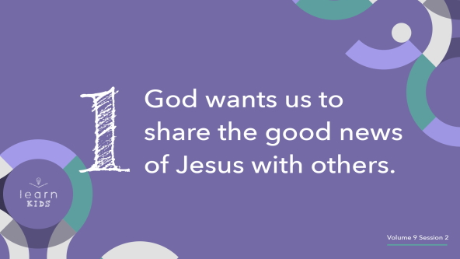

From the moment Paul became a follower of Jesus, he knew his mission from God: Share the good news of Jesus. This was not always easy for Paul. People who believed in Jesus were sometimes treated unkindly by others. Paul himself had put believers in jail before Jesus stopped him and changed his life.

Paul’s life was never the same after he met Jesus! Paul wanted other people to experience Jesus’ love and forgiveness, so he decided to obey when God gave him a very special job. He would go anywhere and everywhere God sent him and share the good news of God’s love.

Even though there are thousands of years between us and Paul, God’s mission is still the same: Tell people about Jesus! Our life may look very different from Paul’s in some ways. But the way we love others and talk about Jesus should look a lot like Paul’s example.

Think about it this way: Imagine you just tasted the best pizza in the whole world. The crust is baked to perfection. The cheese is melty. It has all your favorite toppings. And it’s free to anyone! Who wants some? *(Group response)*

Or imagine you walked into a doctor’s office, and they had a brand-new, free medicine. It would get rid of every disease for whoever took it! Sounds pretty awesome, right? *(Group response)*

The only problem is, no one has heard about the amazing medicine or delicious pizza. What could you do about that? *(Allow responses.)*

News this awesome would need to be shared with others! And is there anything more awesome than the good news of Jesus? What Jesus did, His life, death on the Cross, and resurrection, saves us forever, and it’s a totally free gift! When we believe in Jesus, it’s our job to help share the good news of His love.

**2. We must be ready to share our faith in Jesus.**

• *Show the* ***Teaching Point 2 Slide.***

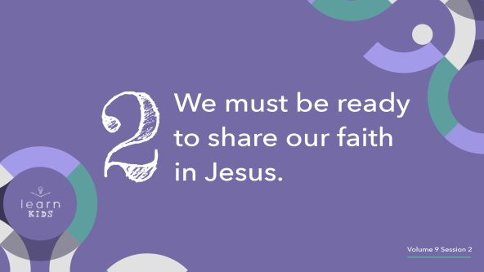

Before Paul shared the story of Jesus with people around him, he had to get ready. The Bible doesn’t tell us exactly how he prepared, but he probably thought about what Jesus had done for him. Then he may have prayed about what Jesus wanted to do for other people. Paul listened to the Holy Spirit’s voice. Paul may have learned more of Jesus’ story by talking to those who knew Jesus best. He learned the stories about Jesus well enough to tell them to others and answer people’s questions.

Think about this. Jesus’ power totally changed Paul’s life. Instead of trying to put followers of Jesus in jail, Paul suddenly wanted to help more people know about Jesus! After Jesus changed his life, Paul talked about his faith in Jesus all the time, everywhere he went. We need to be ready to do the same!

Raise your hand if you have a favorite superhero. *(Group response)* Now keep your hand up if you know that character’s origin story—where the person was born or was like before becoming a superhero. *(Group response)*

Sometimes we know our favorite superhero’s stories better than we know Jesus’ story or how we fit into it. It’s okay to like and enjoy those other things. But we can’t ever let other stories become more important to us than the amazing story of how Jesus lived and died to give us eternal life.

Maybe you’ve never figured out exactly how you would share your faith story with someone else. Don’t worry. We’re going to work on that later. We never know when we might meet someone who needs to hear about what Jesus has done for us. If we’re ready to tell our story like Paul was, God could use it to totally change someone’s life. Don’t miss your chance to be part of that!

**3. God can use our changed life to reach others.**

• *Show the* ***Teaching Point 3 Slide.***

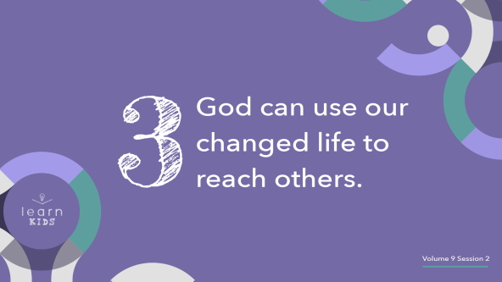

Paul’s faith story was life-changing! He had been famous for hating people who followed Jesus and trying to cause them all kinds of problems. But then he met Jesus!

• *Starting with the “Paul” domino, set up the dominoes in a row as you share the following (or ask a volunteer to help you). At the end, you’ll push the “Paul” domino so the rest of them fall.*

Jesus turned Paul’s whole life around! When other people saw the new Paul, they probably thought about how Jesus could change their life too. God chose Paul to go to different places to tell people the good news about Jesus. Paul gladly spent the rest of his life sharing the good news with people everywhere. He told his story over and over to anyone who’d listen. After hearing about his changed life, people chose to follow Jesus and He changed their life too so the kingdom of God grew.

We also get to be part of that. When we tell others how amazing Jesus is and how He changed our life, they can come to know Jesus too.

• *Push the “Paul” domino over so the others also fall.*

Everyone can have an amazing story because of Jesus. If you haven’t given your life to Him yet, He wants to show you how much He loves you. Jesus can help you become the best you—the one God created you to be. Then you can show others His love too.

When we are changed by God’s love, we grow closer to Him while helping others know His love too. You don’t have to be a pastor or know the whole Bible to be part of God’s mission. You just need to tell your story of faith. How has God has been there for you? How has He changed your life? How has He showed you His love? God can use your story to lead people toward Jesus so He can change their heart and life too!

**Prayer and Response**

*Consider playing a worship song softly in the background while kids pray.*

God wants to do amazing things in us and through us. When we open our heart to Him, He can change our attitudes, behaviors, words, and so much more! He will help us live more like Jesus—full of love and full of truth.

When God changed Paul’s life, he couldn’t wait to tell everyone! Maybe you want to be like Paul and boldly tell the good news of Jesus to everyone around you. God may direct you to use your talents to be a teacher, businessperson, or a plumber. Or maybe God is calling you to do a special ministry job for Him. Some people are called to be ministers who teach and preach about Jesus. Others are called to be missionaries who tell people in other places about Jesus. When we pray in a moment, ask God what He wants *you* to do. Then ask Him for the courage you need to do it.

**Prayer**

• *Have the kids repeat phrases of the prayer after you.*

|  |
| --- |
| Dear God, thank You for giving me a story worth sharing. Help me to be bold like Paul—to do whatever You say and go wherever You send. I want to tell people what You’ve done in my life. I want them to know how much You love them too! Amen. |

Did you feel God calling you to do a special job for Him—like being a minister or missionary? *(Allow responses.)* If that happens, talk to your parents or a leader at church who can help you know what to do next. It’s awesome to be called by God!

• *Optional: Pause and pray with kids who express that they have felt God calling them to ministry.*

• *Optional: Order a few copies of the booklet* Now What? for Kids: Called by God *to help guide kids who are called into ministry.*

**Faith Verse**

Our Faith Verse reminds us that we fulfill God’s mission when we share the truth of His Word with the whole world! Let’s say our Faith Verse and do the actions together.

• *Play* ***Faith Verse Video****.*

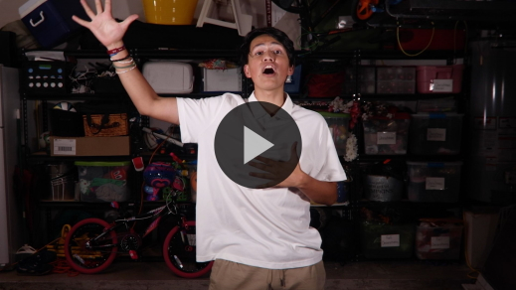

[Matthew 28:19](https://ref.ly/logosref/Bible.Mt28.19) (NLT)

“Therefore, go and make disciples of all the nations, baptizing them in the name of the Father and the Son and the Holy Spirit.”

Remember that one of God’s greatest plans for all of us is to share His love with others!

**Faith Fact**

Before we go to our small groups, let’s say our Faith Fact one more time.

• *Show the* ***Faith Fact Slide****.*



Say it with me. **I will tell others about Jesus**. God wants you to tell other people about Jesus. When Jesus changes your life, you can show everyone what His love and power can do.

• *Dismiss kids to Small Group time or to go home if your group time ends here.*

**Small Group**

**30 Minutes**

*This section can be done in conjunction with the large group or on its own if you do small groups with your kids. During Small Group time, the goal is to connect the kids with the Word of God and to each other. All activities are led by the small group leader.*

**Group Connection**

**Share Your Story**

Who is someone that you want to tell about Jesus and how much He loves them? *(Allow responses.)*

Telling others about Jesus’ love often includes sharing what He’s done in our life too. Let’s take some time to practice telling people how Jesus has changed our life. Sometimes, we can be nervous about sharing what He has done for us. What should we say? How should we say it? The simplest way is to talk about what Jesus has done for us.

Maybe Jesus helped you change your behavior, like He did for Paul. Or maybe He took care of you and your family through a miracle of healing or providing things you needed. If you’ve asked Jesus to be your Savior, tell us about that.

• *Begin by sharing the story of how you became a Christian or something else Jesus has done for you.*

• *Give kids an opportunity to share with each other. Encourage each one as they finish.*

Thank you all for sharing your stories! I love hearing what Jesus has done in your life so far. When we talk about what Jesus has done for us, it encourages others and shows them how He loves us. I can’t wait to see how Jesus uses your stories to help other people know about His love.

**Learn about It**

|  |
| --- |
| ***You Will Need***   * *Bibles for kids in your group to share*   *No prep is needed for this activity.* |

**Scripture Search:** [Psalm 40:9–10](https://ref.ly/logosref/Bible.Ps40.9-10); [Psalm 71:15–16](https://ref.ly/logosref/Bible.Ps71.15-16); [Romans 10:14–17](https://ref.ly/logosref/Bible.Ro10.14-17); [1 Peter 3:15](https://ref.ly/logosref/Bible.1Pe3.15)

Let’s dig deeper into God’s Word and see what else He has to say about telling others about what God has done. As we find and read each of these verses, let’s ask ourselves this question: What does this Scripture mean for our life today?

• *Give each kid a Bible and search for one or more of the Scriptures as a group together (as time allows). When everyone has found the Scripture, have one of the kids read it. Then answer the question about it: What does this Scripture mean for our life today?*

• *Pair kids who need additional help with older kids or start simple and look up the session’s Bible story Scripture:* [*Acts 17:16–34*](https://ref.ly/logosref/Bible.Ac17.16-34)*.* *Kids will get better at finding Scriptures the more they practice.*

• *Optional: Make this a competition to see who can find the Scripture first.*

**Bible Reading Tip**

God’s Word is so good! It’s full of wonderful verses that show us more about who God is. His Word encourages us as we follow Him every day. When you’re feeling sad, afraid, or hopeless, you can look in God’s Word to see what He says about what you’re going through. Reading the Bible might not fix everything right away, but you can find hope and peace when God speaks to you through His Word.

**Challenge**

I want to challenge you today to pick a Bible verse that helps you when you’re feeling upset. Write it down or print it out. Then put it somewhere you will see it every day, like your bathroom mirror or bedroom door. When you read the verse, let God fill you with His hope, joy, and peace. Maybe you could even write your verse on a card and give it to someone else who is feeling down. Who knows? It might be a great way to share Jesus’ love with a friend too.

**Faith Fact**

God’s Word is powerful! It contains God’s message to us about how He made a way to save us through Jesus. That reminds me of our Faith Fact: **I will tell others about Jesus.** Say it with me: **I will tell others about Jesus.** Now shout it with me as loud as you can! **I will tell others about Jesus.**

**Group Discussion**

*Feel free to use all or just a few questions as a jumping-off place for good discussion. Questions marked with * are designed for more conversation. Adjust the questions based on the age or maturity of your group. Typically, older kids will be able to dive a little deeper than younger ones.*

**Questions**

• *If small group activities are not immediately following large group time, you may want to read the Bible story passage before this discussion.*

* What stuck out to you most about our Bible story or the other verses we read?

Why did Paul want to tell others about Jesus so much?

Why does God want us to share the good news of Jesus?

Who can you share Jesus’ story with?

How could God use your faith story to help someone else?

How would you respond if God called you to be a minister or missionary?

* Is it hard for you to talk to others about Jesus? Why or why not?

* Have you shared your faith story with someone before? If so, tell us about it.

**Prayer Requests**

*Finish group discussion by sharing prayer requests and praise reports. Keep track of your small group’s prayer requests and review them each time you meet.*

**Prayer**

*Have kids pray for each other’s prayer requests.*

**Faith Verse Review**

|  |
| --- |
| ***You Will Need***   * ***Small Group Faith Verse Review Page****, one or more per group* * *Card stock* * *Paper cutter or scissors* * *Envelopes, one or more per group*   ***Getting Ready***   * *Print the* ***Small Group Faith Verse Review Page****, one per group.* * *Cut the Faith Verse puzzle into pieces. Place pieces for each puzzle in an envelope. Consider making more intricate cuts for older kids.* |

Our Faith Verse today is [Matthew 28:19](https://ref.ly/logosref/Bible.Mt28.19), which is also known as the Great Commission. This verse reminds us that God wants us to tell people all around the world about Jesus. Let’s watch the video and do the actions for this verse.

• *Play* ***Faith Verse Video****.*



[Matthew 28:19](https://ref.ly/logosref/Bible.Mt28.19) (NLT)

“Therefore, go and make disciples of all the nations, baptizing them in the name of the Father and the Son and the Holy Spirit.”

Jesus said these words to His disciples right before He went back to heaven. God’s mission was super important to Jesus. And it’s important for us too! Let’s review our Faith Verse as a group a couple of more times.

• *Say the verse as a group a couple of times.*

**Faith Verse Fun**

**Puzzle Race**

Now, let’s review the Faith Verse with a game! I’ve turned our verse into a puzzle. When it’s your turn, race to put the puzzle together. Then say the verse as fast as you can.

• *Let kids compete on their own or in pairs to put the puzzle together.*

• *Time them to see how fast they can do the puzzle, and then see if they can break their record.*

Great job, everyone! This verse is one to keep in our mind and heart. It reminds us of how much Jesus wants us to tell others about His love!

**Activity Page**

**Paul Shares His Faith**

|  |
| --- |
| ***You Will Need***   * ***Small Group Activity Page****, one per kid* * *Crayons or markers*   ***Getting Ready***   * *Print copies of the* ***Small Group Activity Page****, one per kid.* |

Paul’s life totally changed after he met Jesus. He got really serious about telling others the good news. In today’s Bible story, Paul was telling people in the city of Athens about Jesus.

• *Give kids time to complete the* ***Small Group Activity Page****.*

• *Talk about the following questions while the kids color.*

Some people laughed at Paul when he talked about Jesus. Have you ever had someone make fun of you because you believe in God? *(Allow responses.)* Other people wanted Paul to talk more about Jesus. Have you ever had someone ask you questions about your faith in God? *(Allow responses*.) Like Paul, we can be prepared to tell others about Jesus.

**Dismissal**

Remember, Jesus wants to use you in a powerful way to tell others about Him. Each of you has a special story of how your life was changed. Jesus can use your story to change someone else’s life too. Let’s close in prayer.

**Prayer**

|  |
| --- |
| *Dear Jesus, please help us boldly share Your story of love and truth. Use us to help other people find out about Your love and choose to follow You. Amen.* |

**Faith Fact Recap**

• *Show the* ***Faith Fact Slide****.*



I’m so glad you were here today! Before we leave, let’s go over the important phrase I want you to remember today. Say our Faith Fact with me one more time. **I will tell others about Jesus.** I’m so glad we got to learn this powerful truth together. I can’t wait to see you next time**.**

• *Send home the* ***Small Group*** ***Activity Page.***

• *Remind parents that there are* ***Family Devotions*** *available on the app to do with their kid.*

• *Tell everyone the date and time for the next session.*